INTRO TO STATISTICS
It’s all about interpreting data (Table, list, graphs, etc)
Data can be form
Population (the entire list of a specified group)
Mean (a subset of the Population)
We usually investigate a small sample of the population to draw conclusions for the whole population itself.
Discrete OR Continuous
R
(finite or numerable set) (interval)
Data can be organized in several ways. We present some examples below
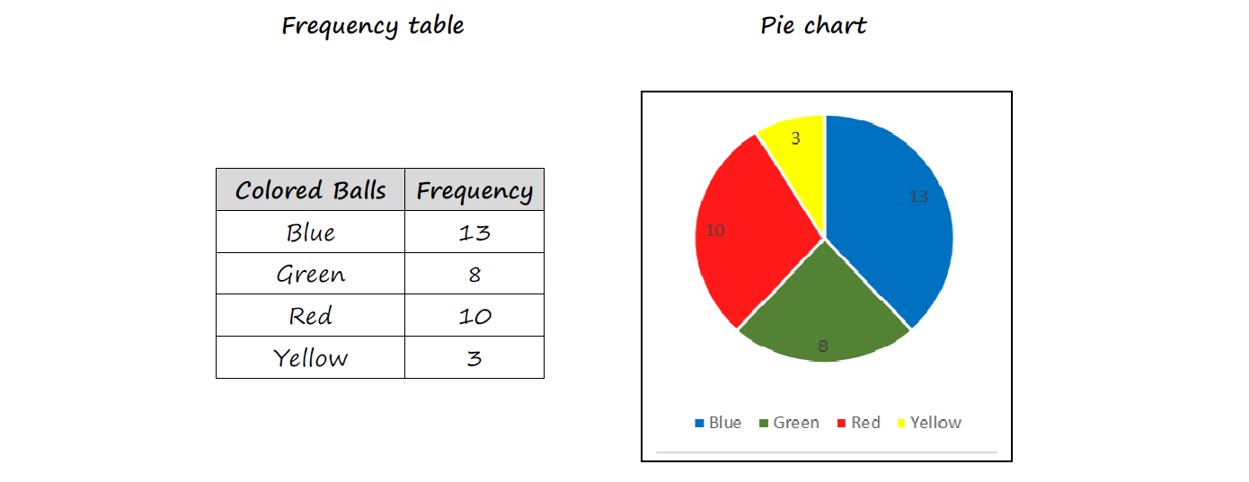

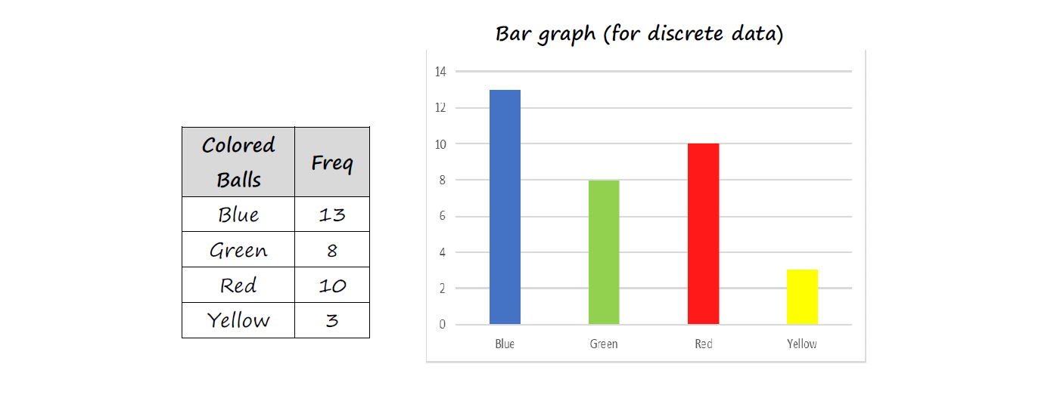
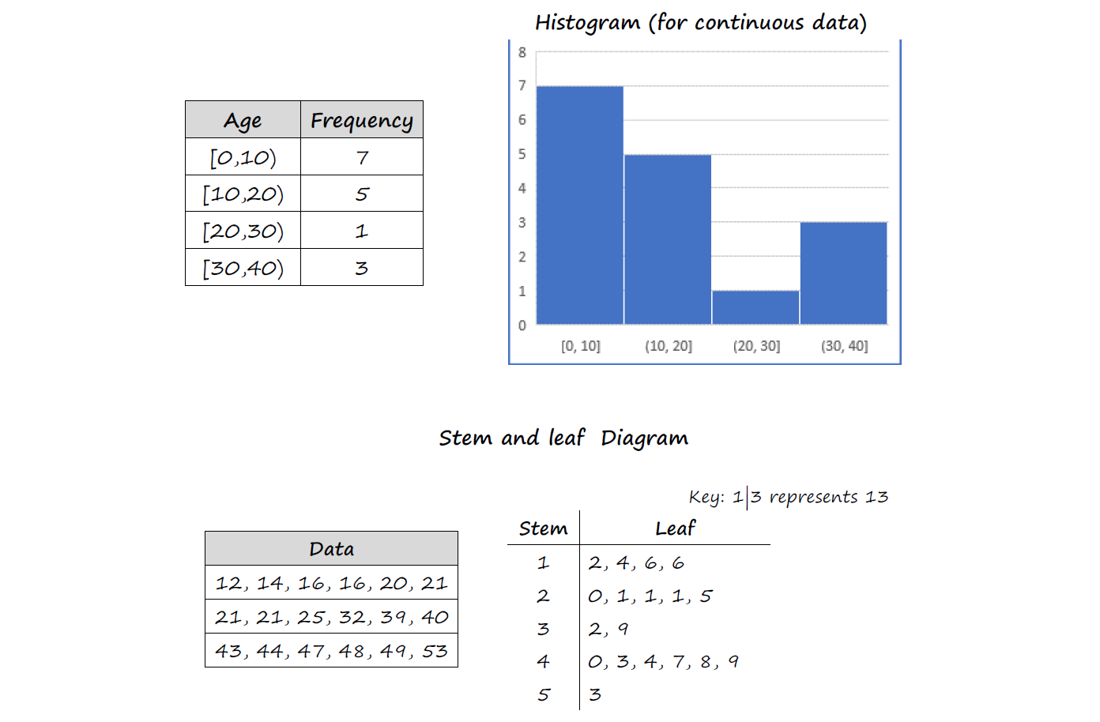
Ex: Age of Students in class:
16,15,17,15,15,16,18,15
Mean:

Notation:
Example: The data below is listed in ascending order:
5, 6, 7, 7, 9, 9, 10, 10, 13, 13, 13, 13, 18
- What is the mean?

Median:

- What is the median of the following data above?

Mode:

Percentile:

Quartile:

Interquartile range (IQR):

Ex: A data set has the following:
25th percentile = 7
50th percentile = 9.5
75th percentile = 13

Mean (Formally):

Example: The height of dinosaurs is shown below:
Height h(m)
Frequency | 5 | 2 | 1 | 2

What is the mean dinosaur height?

SAMPLING AND OUTLIERS

Discrete data:

Continuous data:

Sample:

Reliable data:

Sampling techniques:
- Simple Randon Equal chance of choosing out of a hat, number
generator, etc.
Ex. Poll students from school-# assigned to
Students, choose with random # generator.

- Convenience Choose easiest people to sample: ask your friends.
Problems? May not be representative of population.

- Systematic Choose random starting point, use fixed interval.
Ex. Make a list of all students in a class, choose every 3rd student…
- Quota Sample sizes in proportion to who you’re polling
Ex. 55% girls, 45% boys in school, so sample should have those same %.
- Stratified Spilt into strata (smaller groups)
Ex. Choose half DP1, half DP2 students

